**Global System for Mobile Communications (GSM)**

**What is GSM?**

* [GSM](https://www.geeksforgeeks.org/gsm-full-form/) stands for Global System for Mobile Communication.
* GSM is an open and digital cellular technology used for mobile communication.
* It uses 4 different frequency bands of 850 MHz, 900 MHz, 1800 MHz and 1900 MHz .
* It uses the combination of FDMA and TDMA.
* 2G technology
* Standard developed by ETSI
* Presently GSM supports more than one billion mobile subscribers in more than 210 countries throughout the world.
* GSM provides basic to advanced voice and data services including roaming service. Roaming is the ability to use your GSM phone number in another GSM network.

**Features of GSM are :**

* Supports international roaming
* Clear voice clarity
* Ability to support multiple handheld devices.
* Low powered handheld devices.
* Ease of accessing network
* Compatibility with Integrated Services Digital Network (ISDN) and other telephone company services
* Support for new services
* Low-cost mobile sets and base stations (BSs)
* Subscriber Identity Module (SIM) :
  + One of the key features of GSM is the [Subscriber Identity Module](https://en.wikipedia.org/wiki/Subscriber_Identity_Module), commonly known as a SIM card.
  + The SIM is a detachable [smart card](https://en.wikipedia.org/wiki/Smart_card) containing a user's subscription information and phone book.
  + This allows users to retain their information after switching handsets.
* Phone locking
  + Sometimes [mobile network operators](https://en.wikipedia.org/wiki/Mobile_network_operator) restrict handsets that they sell for exclusive use in their own network.
  + This is called [SIM locking](https://en.wikipedia.org/wiki/SIM_lock) and is implemented by a software feature of the phone.
  + A subscriber may usually contact the provider to remove the lock for a fee, utilize private services to remove the lock, or use software and websites to unlock the handset themselves.

**GSM ARCHITECTURE:**

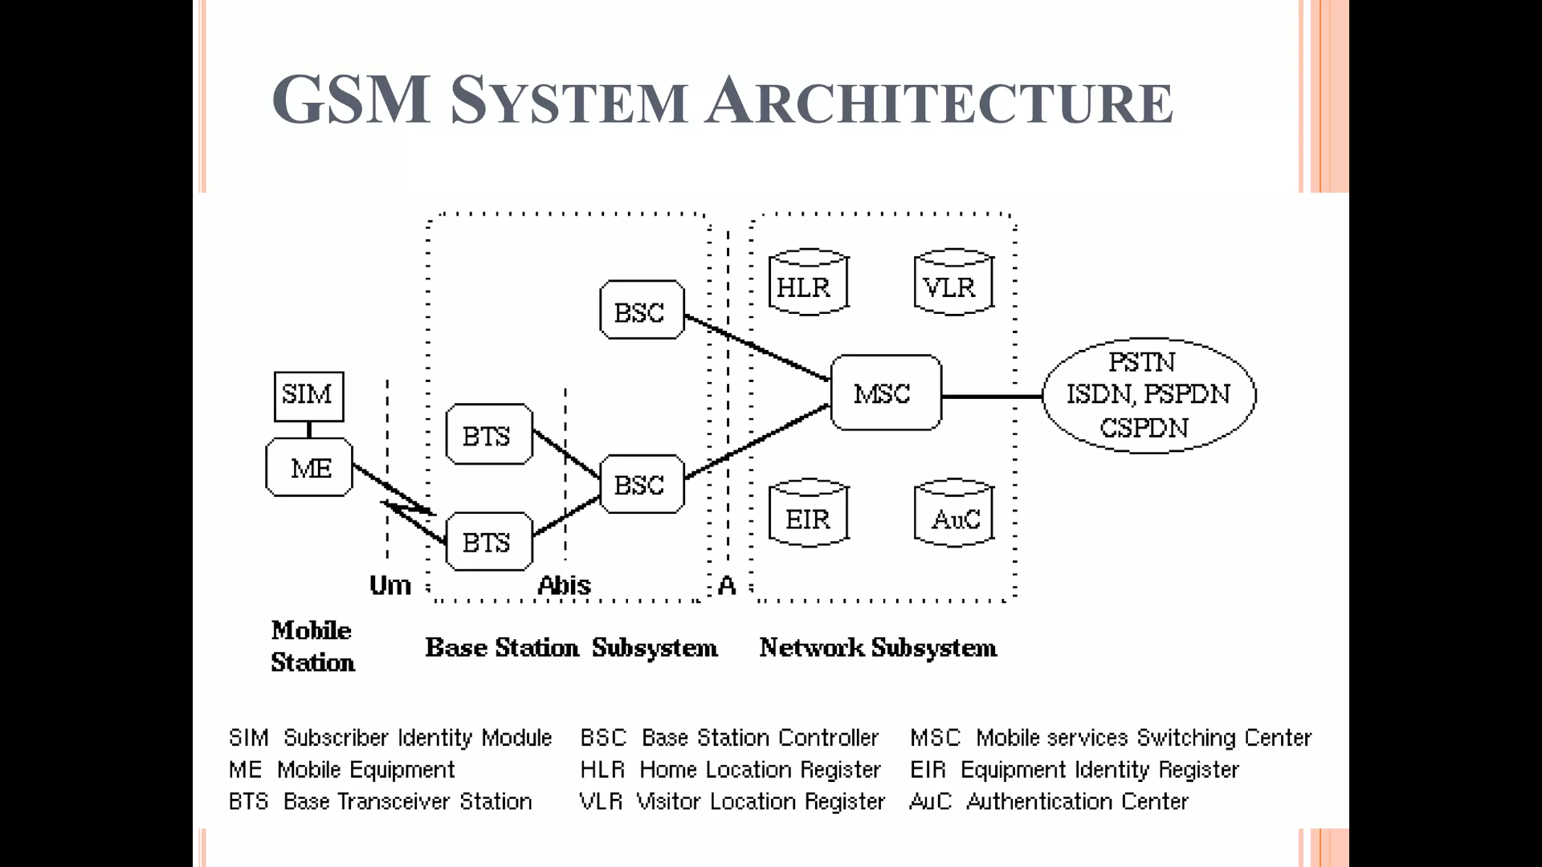

* The GSM network can be broadly divided into −
  + The Mobile Station (MS)
  + The Base Station Subsystem (BSS)
  + The Network Switching Subsystem (NSS)
  + The Operation Support Subsystem (OSS)
* **GSM - The Mobile Station**
  + The MS consists of the physical equipment, such as the radio transceiver, display and digital signal processors, and the SIM card.
  + It provides the air interface to the user in GSM networks.

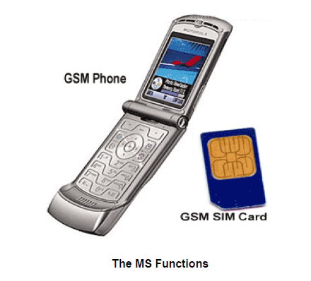

* **GSM - The Base Station Subsystem (BSS)**
  + The BSS is composed of two parts −
    - The Base Transceiver Station (BTS)
    - The Base Station Controller (BSC)
  + The BTS and the BSC communicate across the specified Abis interface, enabling operations between components that are made by different suppliers.
  + The BSS uses the Abis interface between the BTS and the BSC.
  + **The Base Transceiver Station (BTS)**
    - The BTS houses the radio transceivers that define a cell and handles the radio link protocols with the MS.
    - The BTS corresponds to the transceivers and antennas used in each cell of the network.
    - A BTS is usually placed in the center of a cell.
    - Each BTS serves as a single cell. It also includes the following functions −
      * Encoding, encrypting, multiplexing, modulating, and feeding the RF signals to the antenna
      * Time and frequency synchronizing
  + **The Base Station Controller (BSC)**
    - The BSC manages the radio resources for one or more BTSs
    - The BSC is the connection between the mobile and the MSC
    - The BSC also translates the 13 Kbps voice channel used over the radio link to the standard 64 Kbps channel used by the Public Switched Telephone Network (PSDN) or ISDN.
    - It is a switching device that handles the radio resources.
    - Performs traffic concentration to reduce the number of lines from the MSC
* **The Network Switching Subsystem (NSS)**
  + The Network switching system (NSS), the main part of which is the Mobile Switching Center (MSC), performs the switching of calls between the mobile and other fixed or mobile network users, as well as the management of mobile services such as authentication.
  + **Home Location Register (HLR)**
    - The HLR is a database used for storage and management of subscriptions.
    - The HLR is considered the most important database, as it stores permanent data about subscribers, including a subscriber's service profile, location information, and activity status.
    - When an individual buys a subscription in the form of SIM, then all the information about this subscription is registered in the HLR of that operator.
  + **Mobile Services Switching Center (MSC)**
    - The central component of the Network Subsystem is the MSC.
    - The MSC performs the switching of calls between the mobile and other fixed or mobile network users, as well as the management of mobile services such as registration, authentication, location updating, handovers, and call routing to a roaming subscriber.
  + **Visitor Location Register (VLR)**
    - The VLR is a database that contains temporary information about subscribers that is needed by the MSC in order to service visiting subscribers.
    - When a mobile station roams into a new MSC area, the VLR connected to that MSC will request data about the mobile station from the HLR.
  + **Authentication Center (AUC)**
    - The Authentication Center is a protected database that stores a copy of the secret key stored in each subscriber's SIM card, which is used for authentication and ciphering of the radio channel.
  + **Equipment Identity Register (EIR)**
    - The Equipment Identity Register (EIR) is a database that contains a list of all valid mobile equipment on the network, where its International Mobile Equipment Identity (IMEI) identifies each MS.
* **The Operation Support Subsystem(OSS):**
  + The operations and maintenance center (OMC) is connected to all equipment in the switching system and to the BSC. The implementation of OMC is called the operation and support system (OSS).
  + Here are some of the OMC functions:

1,Administration and commercial operation (subscription, end terminals, charging and statistics).

2,Security Management.

3,Network configuration, Operation and Performance Management.

4,Maintenance Tasks.

The operation and Maintenance functions are based on the concepts of the Telecommunication Management Network (TMN), which is standardized in the ITU-T series M.30.

Following is the figure, which shows how the OMC system covers all the GSM elements.

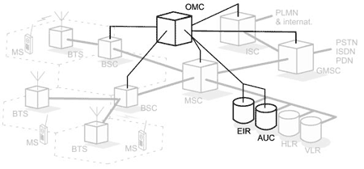

The OSS is the functional entity from which the network operator monitors and controls the system. The purpose of OSS is to offer the customer cost-effective support for centralized, regional, and local operational and maintenance activities that are required for a GSM network. An important function of OSS is to provide a network overview and support the maintenance activities of different operation and maintenance organizations.

**Interfaces**:

Three subsystems **BSS**, **NSS** and **OSS** are connected with each other via some interfaces. Total three interfaces are there:

* **Air Interface**: Air interface is also known as UM interface. Interface between MS and BTS is called the UM interface because it is a mobile analog to the U interface of ISDN. It uses TDMA
* **Abis Interface** : It is a BSS internal interface linking with BTS and BSC.I is based on LAP (Link Access Protocol)
* **A interface** : It provides communication between BSS and MSC

**Multiplexing:**

Whenever the bandwidth of a medium linking two devices is greater than the bandwidth needs of the devices, the link can be shared. Multiplexing is the set of techniques that allows the simultaneous transmission of multiple signals across a single data link.

An efficient system maximizes the utilization of all resources; bandwidth is one of the most precious resources we have in data communications

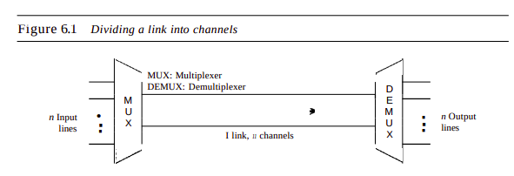

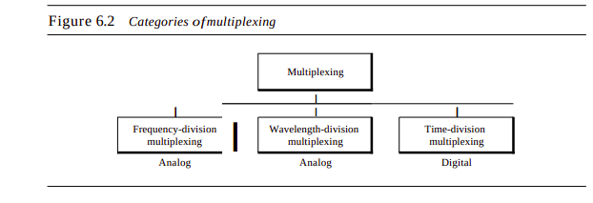

**FDMA(Frequency-division multiple access)**

FDMA is a type of channelization protocol. This bandwidth is divided into various frequency bands. Each station is allocated with band to send data and that band is reserved for particular station for all the time which is as follows

:The frequency bands of different stations are separated by small bands of unused frequency and that unused frequency bands are called guard bands that prevent the interference of stations. It is like an access method in the data link layer in which the data link layer at each station tells its physical layer to make a band pass signal from the data passed to it. The signal is created in the allocated band and there is no physical multiplexer at the physical layer

It was primarily used in 1G and PSTN

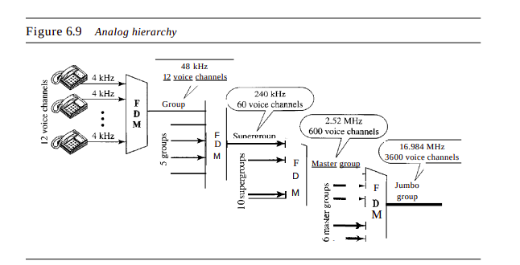

**TDMA(Time Division Multiple Access)**

TDMA is the channelization protocol in which bandwidth of a channel is divided into various stations on the time basis. There is a time slot given to each station, the station can transmit data during that time slot only which is as follows :

Each station must be aware of its beginning time slot and the location of the time slot. TDMA requires synchronization between different stations. It is a type of access method in the data link layer. At each station data link layer tells the station to use the allocated time slot.

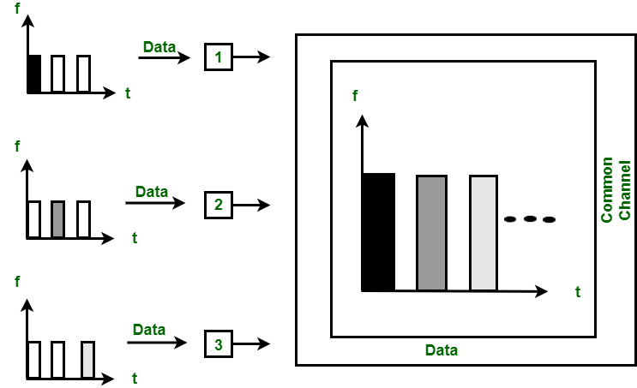

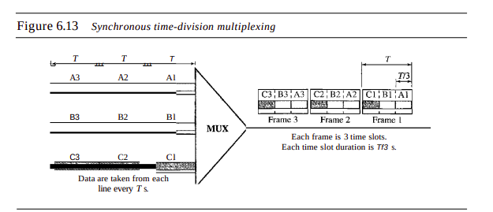

**PSTN** :

PSTN stands for Public Switched Telephone Network. PSTN connects with MSC. PSTN originally a network of fixed line analog telephone systems. Now almost entirely digital in its core network and includes mobile and other networks as well as fixed telephones. The earlier landline phones which are at our home are nothing but PSTN. They are circuit switched networks.

This is the system that has been in general use since the late 1800s. It's the aggregation of circuit-switching telephone networks that has evolved from the days of Alexander Graham Bell.

Using underground copper wires, this legacy platform has provided businesses and households alike with a reliable means to communicate with anyone around the world for generations. Today, it is almost entirely digit

**Circuit Switching :**

The dedicated path/circuit established between sender and receiver provides a guaranteed data rate. Data can be transmitted without any delays once the circuit is established

In-circuit switching has there are 3 phases:

i) Connection Establishment.

ii) Data Transfer.

iii) Connection Released.

**Advantages**:

1,The main advantage of circuit switching is that a committed transmission channel is established between the computers which give a guaranteed data rate.

2,In-circuit switching, there is no delay in data flow because of the dedicated transmission path.

**Disadvantages:**

1,It takes a long time to establish a connection.

2,More bandwidth is required in setting up dedicated channels.

3,It cannot be used to transmit any other data even if the channel is free as the connection is dedicated to circuit switching.

**Advantages Of GSM:**

* The GSM based networks (i.e. base stations) are deployed across the world and hence the same mobile phone works across the globe.
* Advanced versions of GSM with a higher number of antennas will provide high speed download and upload of data.
* The phone works based on a SIM card and hence it is easy to change the different varieties of phones by users.

**Disadvantages Of GSM:**

* GSM provides limited data rate capability, for higher data rate GSM advanced version devices are used.
* In order to increase the coverage, repeaters are required to be installed.